|  |  |  |  |  |  |  |  |  |  |  |  |
| --- | --- | --- | --- | --- | --- | --- | --- | --- | --- | --- | --- |
|  | | **Hope Foundation’s**  **Finolex Academy of Management and Technology, Ratnagiri** | | | | | | | | | |
| **Information Technology Department** | | | | | | | | | |
| Subject name: Big Data Lab | | | | | | | | Subject Code: ITC801 | | | |
| Class | | BE IT | | Semester – VIII (CBGS) | | | | Academic year: 2019-20 | | | |
| Name of Student | | **Kazi Jawwad A Rahim** | | | | | **QUIZ Score :** | | | | |
| Roll No | | **28** | | | Assignment/Experiment No. | | | | | 02 | |
| **Title:**  **Execution of Hive SQL Queries on Hadoop by using HUE interface** | | | | | | | | | | | |
| **1. Course objectives applicable COB1**. To understand main business drivers and key issues of BDA  **COB2**. To acquire knowledge about fundamentals of Big Data Analytics  **COB4** – To handle larger database through BDA framework | | | | | | | | | | | |
| **2. Course outcomes applicable:**  **CO1** : Understand the key issues in big data management and its associated applications in intelligent business and scientific computing.  **CO2** - Acquire fundamental enabling techniques and scalable algorithms like Hadoop, Map Reduce and NO SQL in big data analytics.  **COB4**. Implement use of combiners to consolidate results and ability to handle larger datasets | | | | | | | | | | | |
| **3. Learning Objectives:**   1. To understand the concept of Hadoop User Interface 2. To understand the functioning of Hive SQL, Pig 3. To Execute Hive SQL Query 4. To Execute Pig Script | | | | | | | | | | | |
| **4. Practical applications of the assignment/experiment: Hue is a widely used GUI dashboard for Hadoop** | | | | | | | | | | | |
| **5. Prerequisites**:   1. Knowledge of Hadoop Ecosystem 2. Knowledge of basic SQL queries | | | | | | | | | | | |
| **6. Hardware Requirements**:   1. PC with 4GB RAM, 500GB HDD   **7. Software Requirements:**   1. Ubuntu / Windows , access to internet www.gethue.com | | | | | | | | | | | |
| **8. Quiz Questions (if any): (Online Exam will be taken separately batchwise, attach the certificate/ Marks obtained)**   1. What is a Hadoop? 2. What is SQL? 3. What is Pig Latin? 4. What is Hue? 5. In which language Hue interface is programmed? | | | | | | | | | | | |
| **Sr. No.** | **Parameters** | | | | | | | | **Marks obtained** | | **Out of** |
| **1** | Technical Understanding (Assessment may be done based on Q & A **or** any other relevant method.) Teacher should mention the other method used - | | | | | | | |  | | 6 |
| **2** | Neatness/presentation | | | | | | | |  | | 2 |
| **3** | Punctuality | | | | | | | |  | | 2 |
| **Date of performance (DOP)** | | |  | | | **Total marks obtained** | | |  | | **10** |
| **Date of checking (DOC)** | | |  | | | **Signature of teacher** | | | | | |

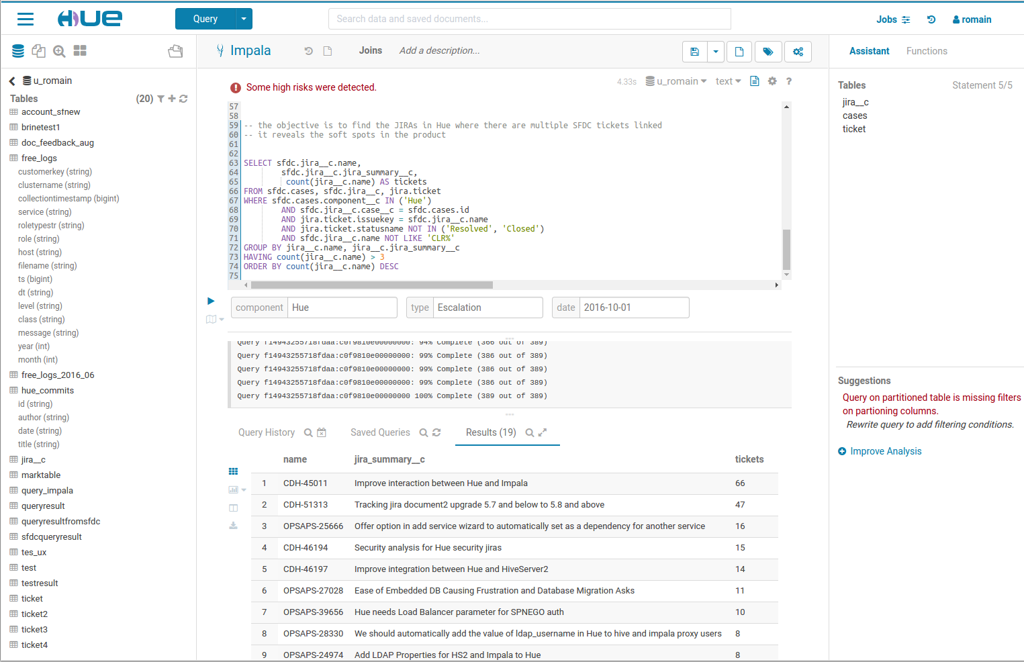

**Figure 1. Hadoop Hue Web Interface**

**2. Precautions** :

1. Internet should be active
2. Copy the Query and its output before executing next query

**3. Installation Steps / Performance Steps -**

1. Open www.gethue.com, login with : Username – demo, password: demo

2. Select SQL Menu and it will display the databases

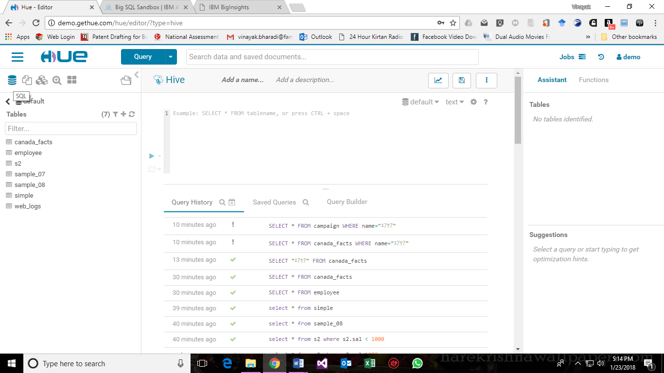

3. Write a Query on available tables :

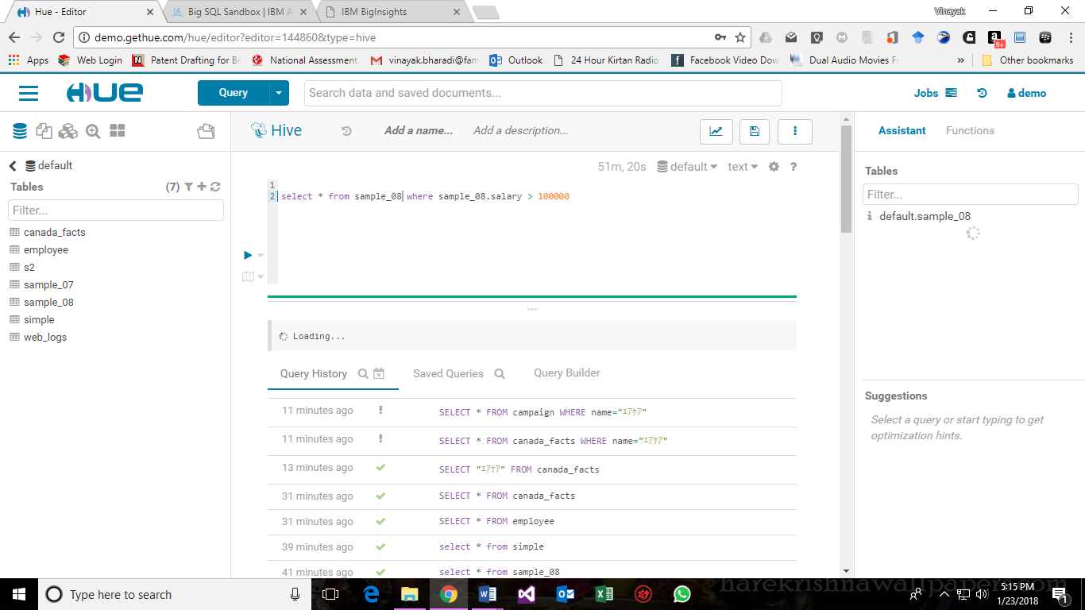

4. Execute the Query:

**4.Observations**

List observations here (if any)

**5. Results:**

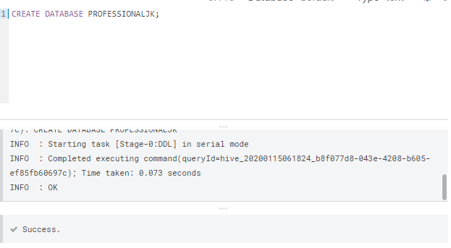

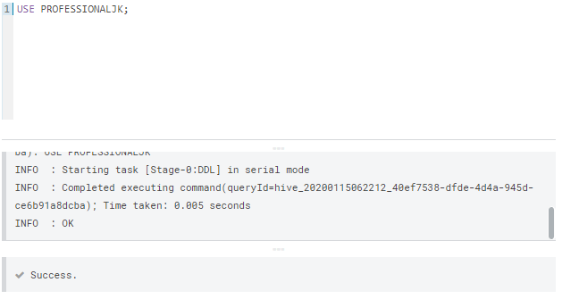

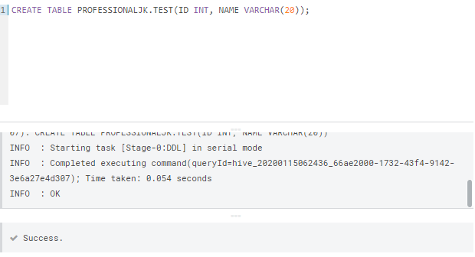

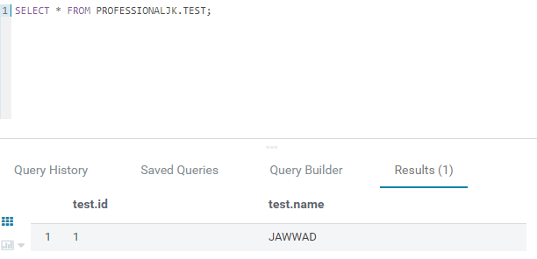

**References** :

[1] Apache Licence : https://github.com/cloudera/hue#license

[2] Hue Live Interface available at : http://demo.gethue.com/hue/accounts/login/?next=/